**Assignment 6 (20 points), SE 421, 9/29/2021, due: Wednesday, 10/6/2021**

**Name (Last, First): Ogbondah, Chimzim**

**Electronic Copy Requirement**: (a) The answers should be typed. (b) The first page should include the top two lines with your last and the first name. (c) Include the question for each answer. (d) The file should be named HW6-lastname-firstname.

**Prerequisite:** Index XINU in Atlas.

**Problem 1(5 points):** Answer the following four questions for the function *ethinter*

1. Create the CFG using Atlas and include it in your answer. (1 point)

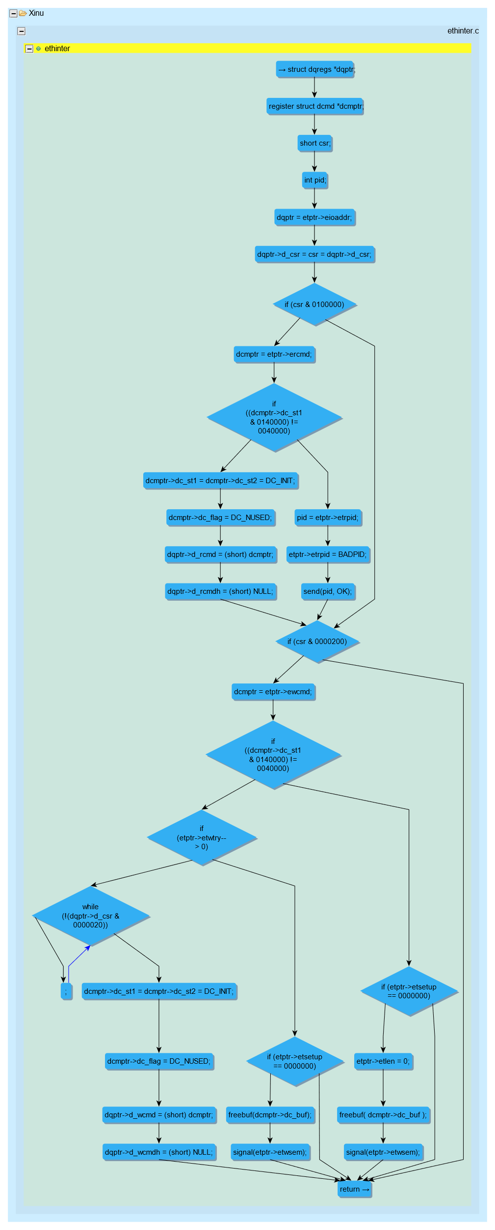

1. For each loop in the CFG mark the Entry node, the successor of the loop, and the back-edges. (1 point)

1. Create and *submit* the *directed acyclic graph* (DAG) that is derived from the CFG to represent the CPM model for loops as an acyclic graph. You can either manually modify the CFG or create the DAG using Atlas queries. (2 points)

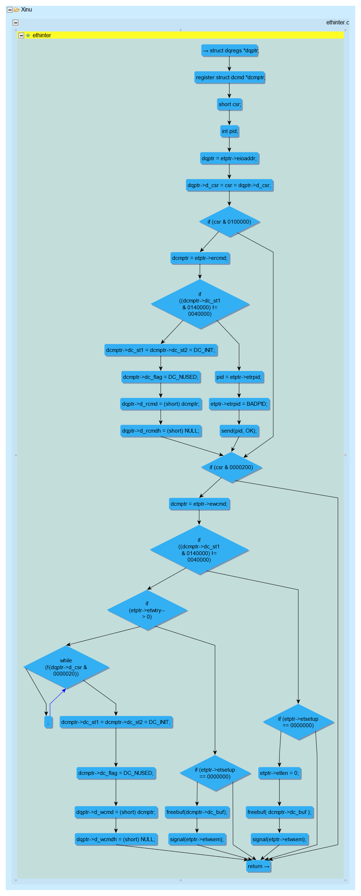

1. Give the number of paths in the resulting DAG (1 point)
   1. 21

**Problem 2 (2 points):** Which one of the following loops can one implement in C without using GO TO? Which statement in that loop must be BREAK?

* Loop 2

a

b

c

e

f

g

h

2

d

a

b

c

e

f

1

h

g

d

**Problem 3 (3 points)** Answer the following questions for the given CFG. How many loops are there? Is there a nested loop? Mark all the back-edges by X (shown here for one loop), How many paths in this control flow graph when back-edges are removed? (Do not add the loop-forward edges.)

* **3 loops, there is 1 nested loop. 3 paths where back edges are removed**

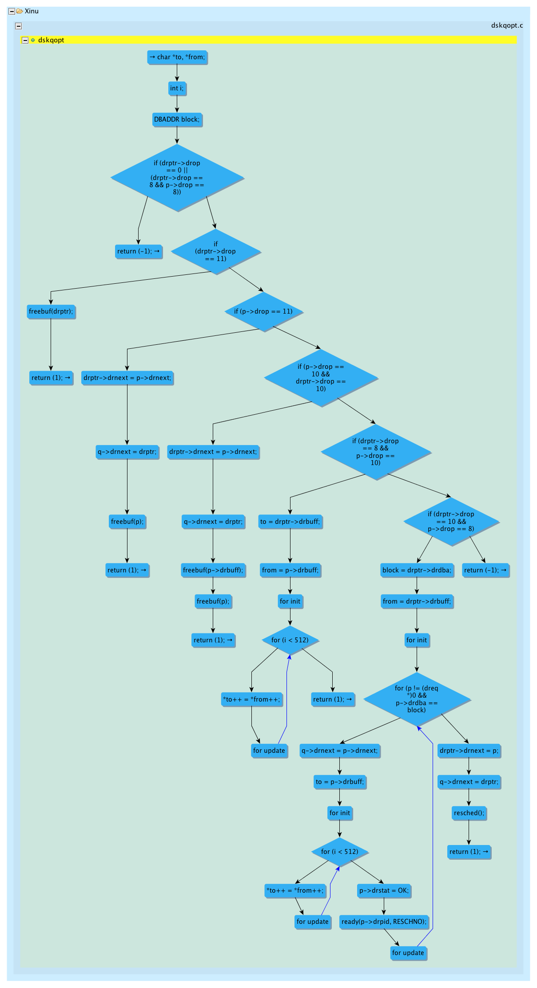

X

X

X

**Problem 4 (3 points):** Graph-2 is obtained from Graph-1 by removing edges and adding loop-forward edges to the successor of each loop. Both graphs have identical nodes but their positions may have changed.

1. Mark the edges in Graph-1 that are deleted in Graph-2. Mark each deleted edge by “D”
2. Mark the edges added in Graph-2 that are not in Graph-1. Mark each added edge by “A”

A

A

A

D

D

D

Graph-2

Graph-1

**Problem 5 (2 points):** Give the *immediate dominator* (idom) for each of the following:

idom(C3) = a1 idom(a4) = c3

idom(a2) = c2 idom(C4) = a3

**Problem 6 (5 points):** Answer questions for the given sequence of queries:

1. Fill in the blanks in queries 9, 15, and 17 so that the graph shown by the last query is the same as the Graph-2 in Problem 4 (the layouts could be different).
2. State what the result is for each query at line 5 and at line 14. (Be specific by mentioning appropriate loop artifacts)
   1. Graphical user interface, text, application, chat or text message

      Description automatically generated
   2. Graphical user interface, text, application

      Description automatically generated
3. You are asked to select the appropriate successor for query 11. How many successors does a loop header have? Which one is the appropriate successor? (Hint: choose the successor so that the graph produced at the end is identical to Graph-2 in Problem 4.)

Note: You need to figure out what each query does. You have been given many clues to do so. If you are not sure, experiment with the query.

1. var x1 = functions(“dskenq”)
2. var x2 = cfg(x1)
3. show(x2)
4. var backEdges = x2.edges(XCSG.ControlFlowBackEdge).retainEdges()
5. show(backEdges)
6. var backEdge = backEdges.eval().edges().one()
7. show(toQ(backEdge))
8. var loopHeader = backEdge.to()
9. var successors = x2.successors(**toQ(loopHeader)**)
10. show(successors)

/* Use the appropriate successor of the loop header*/

1. var successor = selected
2. var tail = backEdge.from()
3. var contEdge = Graph.U.createEdge(tail, successor.eval().nodes.one())
4. show(toQ(contEdge))
5. var dag = x2.differenceEdges(**toQ(backEdge)**)
6. show(dag)
7. dag = dag.union(**toQ(contEdge)**)
8. show(dag)